Lab 1

Map 1.

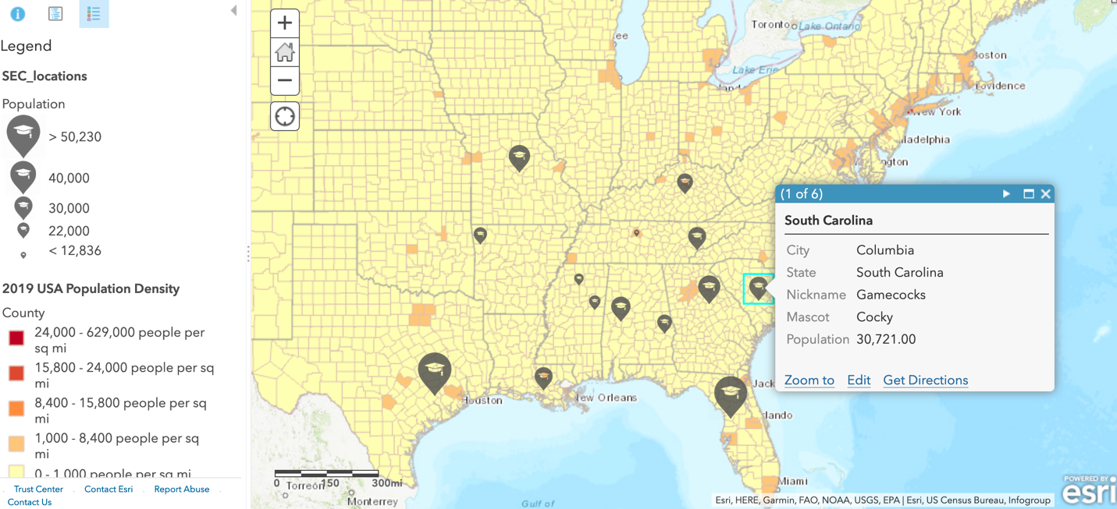

<https://arcg.is/00iru9>

Questions 1.

1.Why did you select to display this particular area of the United States?

I chose this view to show the entirety of the SEC schools while simultaneously highlighting population differences of the schools versus the population of each of the counties around the large universities. I felt it was best to get a clear view of the entirety of the regions around the Universities as well as them compared to eachother to better be able to analyze population differences.

2.Why did you decide to symbolize the locations of the SEC Universities as you did?

I chose to symbolize each university with an educational marker because it seemed to fit the particular institution we were highlighting. In addition, I chose to make the size of the marker change by size to make a more user friendly and easily readable map without having to display too much information behind popups.

3.Why did you select this particular esri basemap?

I selected the topographic basemap due to its ease of readability and lack of clutter due to the fact that the counties layer added many polygons to the United States. The streets view map was another option that I was leaning towards, however the similar colors to the counties layer and the fact that I enjoyed the yellow-red color scheme on it eventually led me to choose the topographic basemap to both differentiate region of interest in the map and maximize readability.

4.Why did you select the other layer from the web you did?

I selected the counties layer because it mapped an interesting juxtaposition with the University size by population. I found it interesting how increased county size did not necessarily correlate with increased University size and it led to the conclusion that University location may not play as big of a role in student body as one may think.

Map 2.

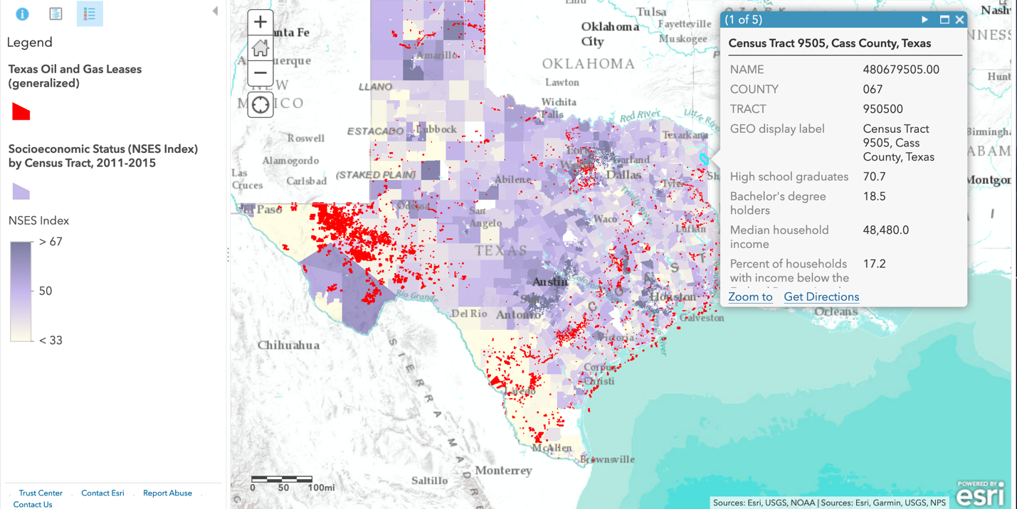

<https://arcg.is/1O9eLC>

Questions 2.

5.Why did you select to display this particular area of the United States?

I chose this area because Texas is the state that I call home and, with a large oil industry in the state it was a natural choice for displaying the two types of data I was interested in analyzing. It had both personal interest and effect on my home state as well as me having a prior knowledge of the possible correlation of the two variables.

6.Why did you decide to symbolize the layers that you did?

I symbolized the income based on the NSES (Neighborhood Socioeconomic Status Index) which quantifies median income as 50 and bases it’s ranges off of that. A color gradient was a natural choice to show this kind of data, and due to the small size of some of the Leases’ polygons in the other layer I chose to show them in a bright, contrasting red. In addition, I chose to enable popups for the economic layer so that more accurate income and even graduate data could be used to better analyze the interplay of the two layers.

7.Why did you select this particular esri basemap?

Due to the fact that the NSES index layer so very transparent and involves slight color variations I chose to put a black/white Terrain With Labels map, which also provided convenient labels visible under the income data. In addition, it helps highlight the borders of the map of Texas due to the juxtaposition of white and color.

8.Why did you choose to represent these two layers together?

I chose to represent Income in NSES compared to oil leases to get a better idea on how oil leases are spread throughout the state socioeconomically. I initially assumed that higher oil leases would correlate to higher median income, however when graphed the opposite seemed true (except in a few cases). The most likely explanation for this is that higher income areas are concentrated in urban centers and generally more rural areas are used for drilling while the businesses are located in the urban centers.